Sprint 4

Lessons Learned
The lessons learned document was written by our documentation specialist, Hadas, and is attached in a separate file named “Lessons Learned Memo – Sprint 4.docx.”

List of Complete Customer Events
Below, you will find the list of User Stories the C# team considers complete.
User Story | Description | Priority | Time Required
(Complete) Medicaid Applicant | As someone who doesn’t know much about Medicaid or the process to get approval, I want to learn more about the program through the MEVA app so that I can understand how to get the proper coverage. | High | 2 sprint, 1 person, 10 hours
(Complete) Medicaid Applicant | As a Medicaid Applicant, I want to be able to upload documentation for any verification I need to provide during the application process. | High | 2 sprint, 1 person, 8 hours
(Complete)  Document Specialist | As a documentation specialist on this project, I want all of the documentation to be readily available and up to date in the GitHub repository. | High | 6 sprint, 1 person, 2 hours
(Complete) Database Developer | As a database developer on the MEVA project, I want to connect the database layer to the API layer, so that captured data is safely stored for later reference. | High | 1 sprint, 1 person, 10 hours
(Complete) Software Developer | As a software developer for the MEVA project, I want to ensure that the logged in user can only access areas of the site that they are authorized to access. | High | 6 sprints, 1 person, 20 hours
(Complete) Medicaid Employee | As a Medicaid employee, I want to have access to a dashboard that organizes applicant data so that I can more easily review their applications. | Medium | 1 sprint, 1 person, 15 hours

User Stories Chosen for This Sprint
Below, you will find the list of User Stories which were in scope and actively worked on for Sprint 4.
User Story | Description | Priority | Time Required
(Current) Medicaid Employee | As a Medicaid Employee, I want to view a recipient’s employment hours, employer information, and any other needed documentation in one place so that I can quickly verify whether the recipient meets the work requirement for Medicaid eligibility. | High | 2 sprints, 2 people, 20 hours
(Current) Medicaid Employee | As a Medicaid employee, I want to be able to notify an applicant if their provided documentation is not suitable to be used for verification. | Medium | 1 sprint, 1 person, 5 hours
(Current) Medicaid Applicant | As a Medicaid recipient, I want to be able to see the status of my submitted verification documents so that I can know whether my information has been accepted or if I need to provide something else. | High | 2 sprint, 1 person, 12 hours
(Current)  Software Developer | As a software developer on this project, I want to get the MEVA web app to a state where it can be tested by non-developers. | High | 3 sprints, 2 people, 30 hours
(Current) Web App User | As a user of the MEVA application, I want the application to display properly on both desktop and mobile devices so that I can use either to access the web app. | Medium | 2 sprints, 1 person, 10 hours

Code For Completed Work
The code for this sprint was all written by Josh.
All the code for work completed thus far can be found in the C# team’s repository, found at https://github.com/Hadas-26/C---System-Analysis-Design. Here is a direct link: Hadas-26/C---System-Analysis-Design.

Monkey Survey Questions & Results
Here are the questions asked in the Survey Monkey survey:
- How easy was it to navigate the web app?
  - The mean score is currently 94.43%. This score was collected via a slider where higher values meant the website was seen as easy to navigate.
- Describe any issues you faced during the employment verification process.
  - The only issue described was slow initial loading times for the app by 1 respondent, and this is expected on the free Azure tier on which the site is hosted.
- What did you like most about the web app?
  - A summary of responses would be ease of navigation, simple design, colors chosen, and one respondent appreciated the eligibility requirements listed on the home page.
- What improvements would you suggest for the web app?
  - Respondents suggest adding more to the UI design, saying it’s a little too plain.
- Please rate the visual appeal of the web app.
  - We scored a 4.43 out of 5 stars in this category.
- How satisfied were you with the speed of the web app?
  - We are currently rated 97.86 on speed based on the mean average of responses to this question.
- Would you recommend this web app to others?
  - We scored an 82% on this question based on the mean.
- How likely are you to use this web app again?
  - We scored a 72.71% on this question based on the mean.
- How would you describe your overall experience using the web app?
  - Respondents said that the app is adequately functional, the experience was good, some say they are impress while others call the app lackluster.
- Provide any additional comments or suggestions you have.
  - There was only 1 person who gave advice. They seemed to suggest more things to do or see on the App.

ORD
The Object Relational Diagrams relating to our Sprint 4 User Stories were produced by our diagram specialist, Evi. These diagrams will be submitted alongside this report as a pdf titled Sprint4_ORD.pdf

BPD
The business process diagram was produced by our new member, and our second diagram specialist, Brett. After discussing the BPD as a team, we believe we understand the differences between a flow chart and a Business Process Diagram and will make every effort to produce the correct diagram for the next Sprint. For this Sprint, we’ve only produced two diagrams for a lack of time. Below, you will find the diagrams.
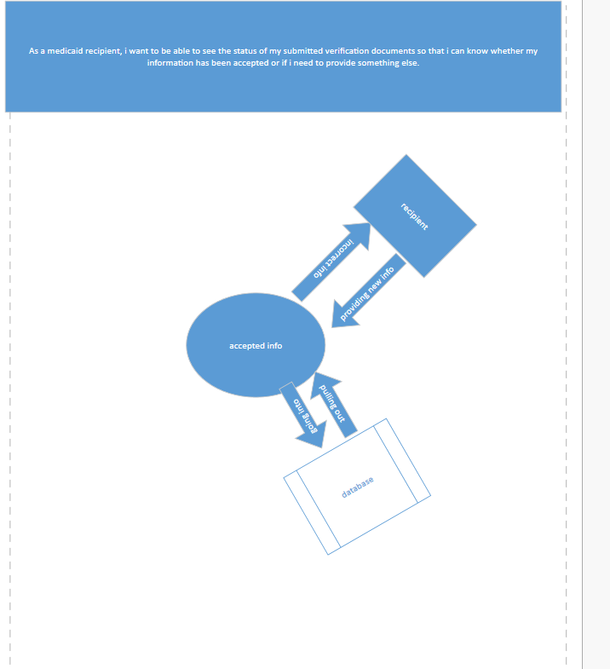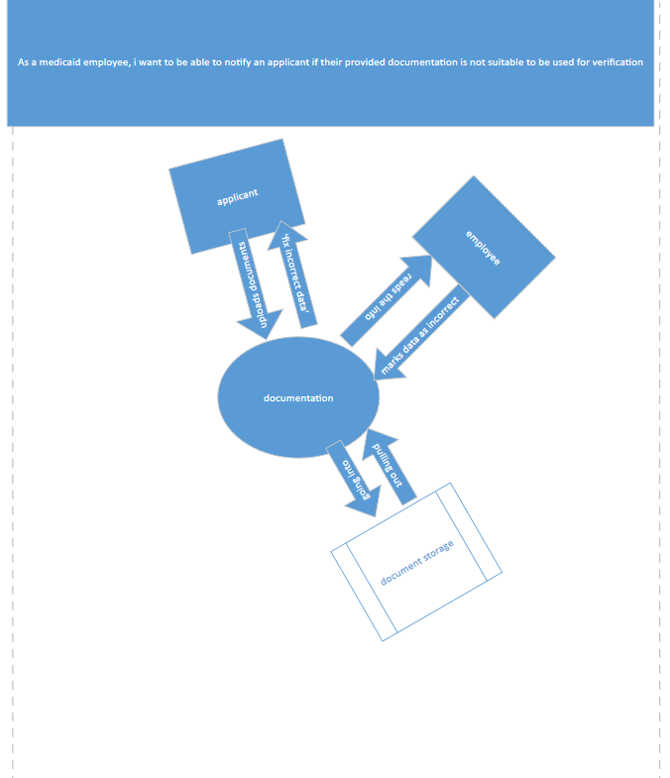

Testing
Testing was performed by Josh, and all users who took the monkey survey. There are currently no known bugs in the program. There is currently no restriction on applicants submitting multiple applications, which will need to be changed in the future but is purposely unrestricted while development is in these early stages.

Code Documentation
Code documentation (created and is maintained by our documentation specialist, Hadas) can be found below.
- Project Overview​
The Medicaid Document Portal is a web-based application prototype designed to help Medicaid employees manage and review documents submitted by applicants.​
The purpose of this application is to make the document verification process easier, more organized, and more efficient. It provides a central place where employees can view application information, review submitted documents, and track application statuses.​

What The Code Does
- The code creates the user interface for the Medicaid Document Portal. It provides different sections to help users navigate the application and access important information. The main features include: ​
- Dashboard: Displays an overview of applications and document activity. ​
- Upload Documents: Provides an area for submitting or uploading required documents. ​
- Document Review: Allows employees to review applicant documents. ​
- Application Status: Helps employees track which applications are pending or completed. ​
- Profile: Displays user profile information. ​
- Help: Provides access to assistance and application information. ​
- The dashboard also displays summary information, such as total applications, pending reviews, and documents. ​

Who Will Use The Application
- The primary users of this application are: Medicaid Employees: Employees use the portal to review applicant information, verify submitted documents, and monitor application progress. Document Reviewers: Reviewers use the application to check submitted documents, identify missing information, and update document statuses. Applicants: Applicants are the intended users of the document submission process. They need a way to provide required documents and understand the progress of their applications. ​

Platform Requirements For Hosting
- The Medicaid Document Portal is designed as a web and mobile based application. Users will access the application through a web browser on a computer and phone. ​
- Software Requirements The expected software requirements include: ​
- Windows 10 or Windows 11 operating system. ​
- Microsoft Edge or Google Chrome web browser. ​
- Visual Studio Code or another code editor for development.​
- HTML for creating the application structure. ​
- CSS for designing the user interface. ​
- JavaScript for interactive features, if implemented. ​
- A database management system may also be required for future development to store applicant information, submitted documents, and application statuses.​

Platform Requirements For Users
- Hardware Requirements​
​
The recommended hardware requirements include:​
• A desktop computer or laptop.​
• A minimum of 4 GB RAM, with 8 GB recommended.​
• A modern processor.​
• Internet connection.​
• Sufficient storage for application files and documents.​
- Mobile device ​

Security and Future Improvements​
Because the application involves personal and employment information, security is important.​
Future development should include:​
- Secure employee login and authentication.​
- Different access permissions for employees and applicants.​
- Protection of personal and confidential information.​
- Secure document storage.​
- Database integration.
- Error handling and application testing.​

Conclusion​
The Medicaid Document Portal is designed to improve the way Medicaid employees manage applicant documents and application information. The application provides an organized interface for document review and status tracking.​
Future development will focus on improving functionality, connecting the database, strengthening security, and testing the application to make sure it meets the needs of its users.​

Recommendations And Additions
- The C# team recommends adding accessibility features for users who may need it.​
- We recommend adding padding to the hamburger menu links to make them easier to click.​
- Lastly, we recommend considering auto fill functionality for known information (first name, last name, email) in an application for users to save time.​

